


University of Jordan
School of Business
Business Intelligence And Data
Supervisor: Dr. Mutaz Al-Debei
Project subject: Sales Story Line
Name | ID
Tareq Reda Shames Aldeen Abdeen | 0223559
Wadee Bashar Suliman Abbassi | 0227851

2nd Semester 2025

Contents
Introduction: 3
Data Engineering 4
A. Fact Sales: 4
B. Dimension Regions: 5
C. Dimension Products: 6
7
D. Dimension Time: 7
E. Dimension Customers: 8
Data Modeling: 9
DASHBOARD ANALYSIS: 11
Key Metrics Cards (Top Section): 12
A. Total Revenue: 13
B. Average of Total Sales: 13
C. Product Count: 13
Total Sales by Customer Segment (Bar Chart): 14
Monthly Trend – Total quantity (Area Chart): 15
Sales Distribution by Product Category (Funnel Chart): 15
Median of Total Sales by Category (Donut Chart): 16
Sales Contribution by Country (Ring Chart): 17
Drill Through: 17
Drill Up: 18
Drill Down: 19
Monthly Revenue by Product Category (Line Chart): 20
Sales Performance by Country (Map): 21
Revenue Per Unit Analysis (Bar Chart): 21
Customer Segment Distribution (Waterfall Chart): 22
Total Revenue by Month (Column Chart): 23
Reference: 23
Conclusion: 23

Introduction:
This project focuses on building an interactive sales analysis dashboard using Microsoft Power BI. The goal is to turn raw sales data into meaningful insights through visual storytelling, helping decision-makers understand performance trends across product categories, regions, and customer segments.
We began by cleaning and transforming the data using Power Query. This included removing duplicates, fixing data types, handling missing values, and creating calculated columns such as monthly sales, average quantity, and revenue per unit. These steps ensured the data was accurate, consistent, and ready for analysis.
Next, we developed a structured data model using star schema principles. Relationships between fact and dimension tables were defined clearly, and hierarchies were created for time and geography to allow detailed filtering and drill-down analysis. This modeling step made it easier to explore data from different perspectives.
The final output is a multi-page dashboard called “Sales Storyline.” It includes KPIs like total sales, average transactions, and category contributions. Visuals such as bar charts, line graphs, funnel diagrams, and maps were used to show trends, segment behaviors, and regional performance.
Overall, this project highlights how data transformation, modeling, and visualization can work together to deliver a clear and interactive report. Power BI was used not just as a visualization tool, but as a complete solution for transforming raw data into valuable business insights.

Data Engineering:
Data engineering in Power BI plays a critical role in preparing and shaping data for analysis. It involves importing raw data from various sources, cleaning it, transforming it using Power Query, and organizing it into structured models. This process ensures that the data is accurate, consistent, and ready for building interactive visualizations and reports. With Power BI’s powerful data transformation tools, we can automate data preparation and create efficient data models that support deeper business insights.

Fact Sales:
The following modifications were made to the data: The data types were changed and columns were renamed. After that, some values were replaced and duplicates were removed.
A custom column was added and data type was changed, and finally, the average was calculated.
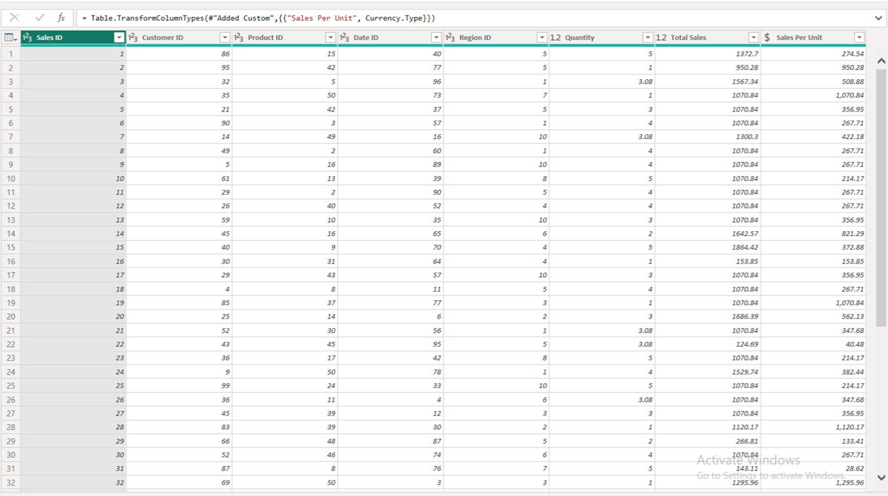
Figure 1: Fact Sales Clean

Dimension Regions:
Data transformations shown in the image: the query named ‘Dimension- Regions. Clean’, has undergone several cleaning and structuring steps. Data types were adjusted, words were capitalized, and columns were renamed for clarity. Finally, duplicate entries were removed to ensure data integrity.
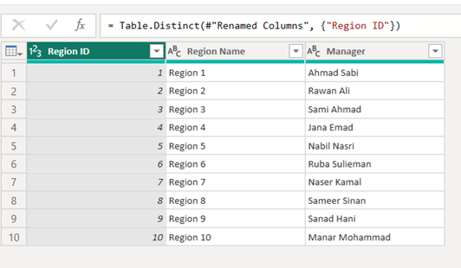

Figure 2: Dimension Region Clean

Dimension Products:
Data transformations for ‘Dimension Products’: This dataset has undergone a series of cleaning and refinement steps. transformations included changing data types, removing duplicates, renaming columns, and replacing specific values. Additionally, text formatting was applied by capitalizing each word in relevant fields, and a calculated average was derived to enrich the dataset.

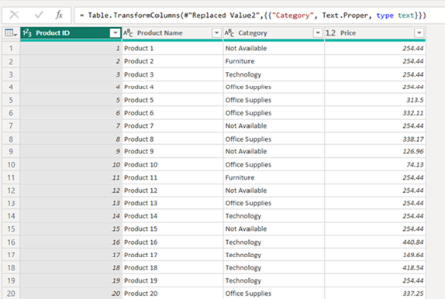

Figure 3: Dimension Products Clean

Dimension Time:
Data transformations for the ‘Dimension Time’ query: This dataset has undergone a series of steps to ensure data quality and usability. Data types were adjusted, columns were renamed for clarity, and duplicate entries were removed to maintain data integrity. Finally, an additional data type change was applied to refine the dataset further.
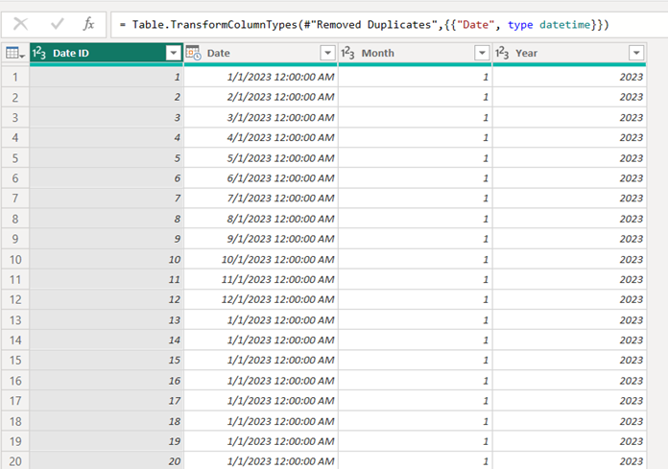

Figure 4: Dimension Time Clean

Dimension Customers:
Data transformations for the ‘Dimension Customers’ query: This dataset has undergone extensive cleaning and standardization. The process began with adjusting data types, renaming columns, and removing duplicates. Then capitalizing each word in relevant fields, replacing specific values, and updating text entries to ensure consistency and accuracy across the customer dimension.
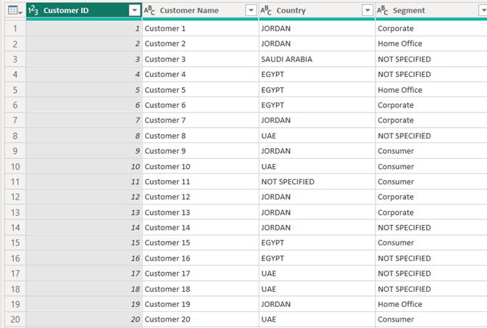

Figure 5: Dimension Customers Clean

Data Modeling:
The model centers around the Fact Sales table, which contains key transactional data such as Quantity, Sales Per Unit, Total Sales, and Total Revenue. Surrounding this fact table are several dimension tables: Dimension Time (with attributes like Date, Day, and Month), Dimension Customers (including Customer Name and Segment), Dimension Regions (with Region Name and Manager), and Dimension Products (featuring ProductName and Category). These dimensions are linked to the fact table through common keys like Product ID, Region ID, and Customer ID, enabling efficient filtering and aggregation. The inclusion of calculated measures such as Mean Fact Sales further enhances analytical capabilities. Overall, this design ensures clear relationships, simplifies complex queries, and supports high-performance reporting in Power BI.
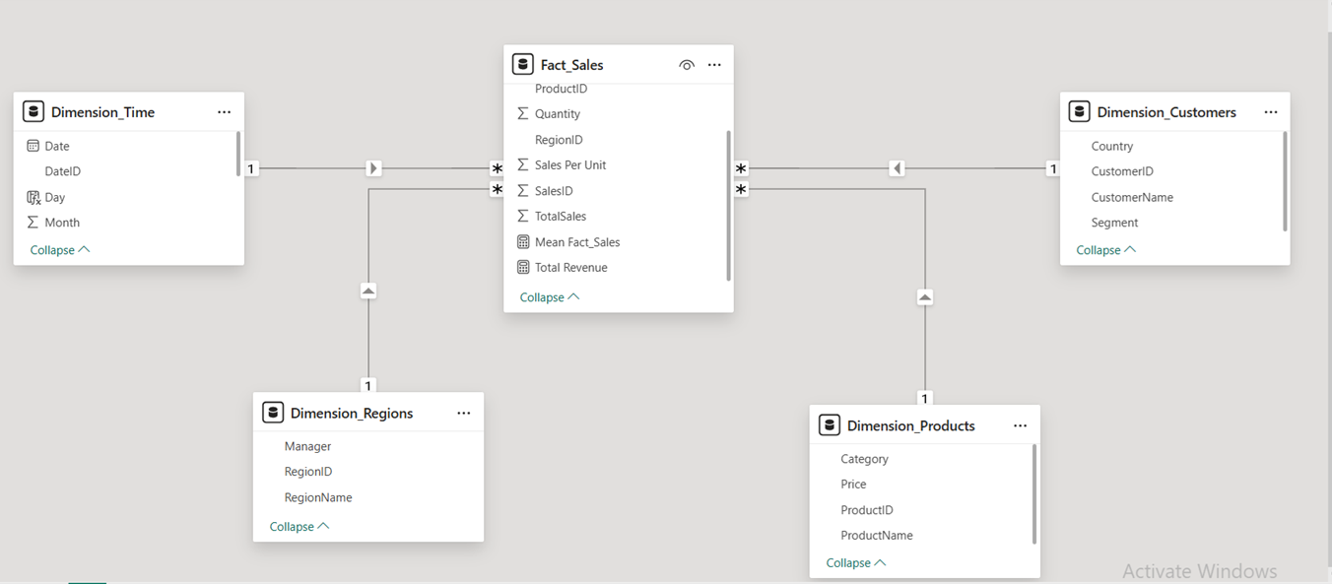
Figure 6: Model View

DASHBOARD ANALYSIS:
This Power BI dashboard, titled “Sales Storyline”, presents a comprehensive analysis of a company’s sales performance across different customer segments, product categories, countries, and time periods. It is designed to provide quick insights into sales volume, trends, and business opportunities by using multiple interactive visualizations. The dashboard is structured in two main tabs: Sales Analysis and Revenue Analysis, each containing several charts and KPIs that enable data-driven decision-making.
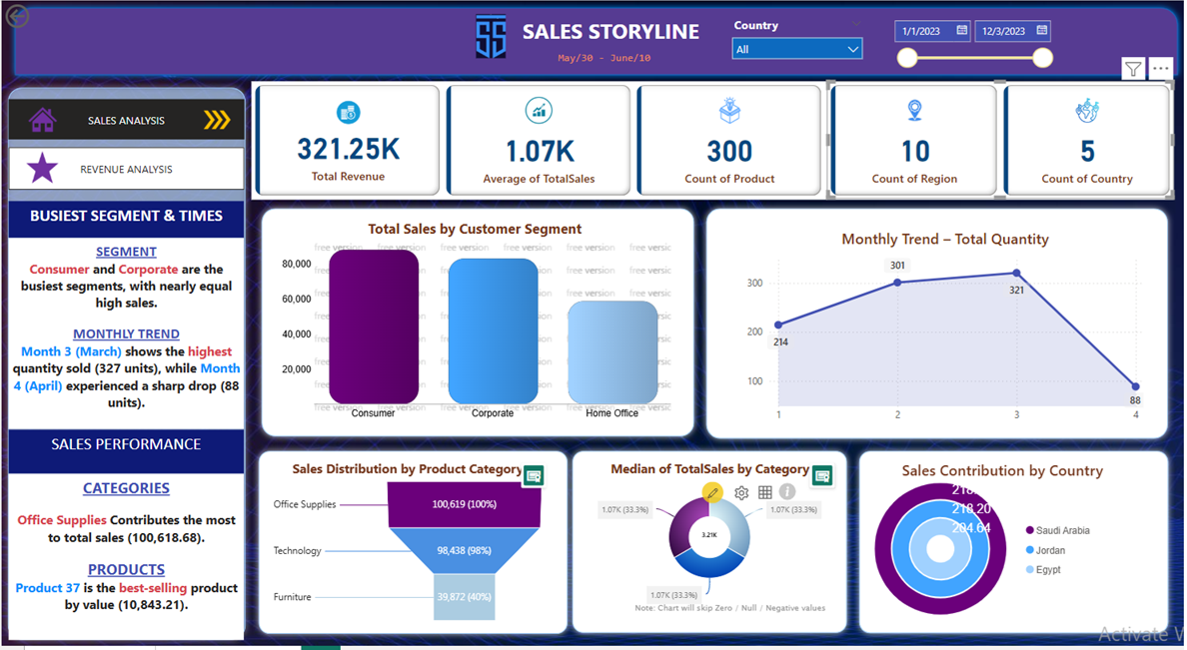

Figure 7: Sales Analysis
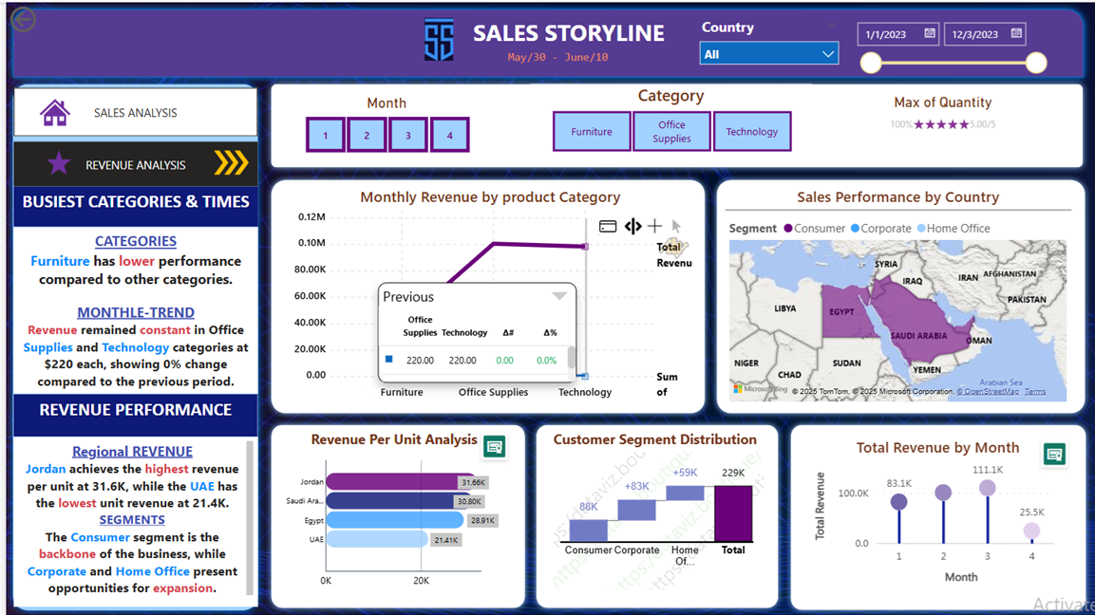
Figure 8: Revenue Analysis

Key Metrics Cards (Top Section):
• Total Sales Revenue – Displays total revenue (321.25K).
• Average of Total Sales – Average value per transaction (1.07K).
• Product Count – Number of unique products (300).
• Region Count – Number of sales regions (300).
• Country Count – Number of countries involved (100).
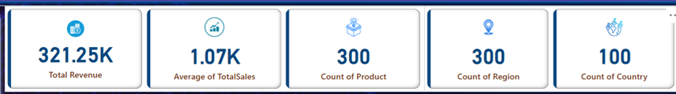
Figure 9: Cards
- Total Revenue:
• Insights: Shows the overall revenue generated from all sales (321.25K).
• Why this chart? A KPI card provides a quick, high-level overview of performance.
• Benefits: Instantly tells the user the scale of business performance.
• Decisions: Use this number to evaluate overall business growth or decline.

Average of Total Sales:
• Insights: Displays the average value of sales per transaction (1.07K).
• Why this chart? Helps understand revenue quality per sale, not just quantity.
• Benefits: Highlights efficiency and pricing of sales.
• Decisions: Decide if pricing strategy or customer value optimization is needed.

C. Product Count:
• Insights: Shows the number of unique products involved in the sales data (300).
• Why this chart? Useful for understanding product variety and catalog size.
• Benefits: Helps track inventory diversity.
• Decisions: Evaluate whether to expand, limit, or optimize the product range.
D. Region Count:
• Insights: Indicates how many regions were covered by the sales data (300).
• Why this chart? Helps assess geographic distribution of the business.
• Benefits: Measures the spread and penetration of the business.
• Decisions: Consider expanding into underserved or highly active regions.
E. Country Count:
• Insights: Reflects the number of countries contributing to the sales data (100).
• Why this chart? Supports understanding of global business reach.
• Benefits: Shows international market engagement.
• Decisions: Consider global marketing or supply chain strategies based on country performance.
Total Sales by Customer Segment (Bar Chart):
• Insights: This chart shows which customer segment (Consumer, Corporate, Home Office) generates the highest total sales.
• Why this chart? Bar charts are ideal for comparing discrete categories side by side.
• Benefits: Helps identify the most valuable customer segment.
• Decisions: Focus marketing efforts and resources on the highest-performing segment.

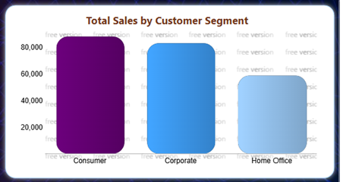
Figure 10: clustered bar chart

Monthly Trend – Total quantity (Area Chart):
• Insights: Displays how the total quantity of sales varies from month to month.
• Why this chart? Line charts are best for showing trends over time.
• Benefits: Allows the business to detect seasonal patterns or drops.
• Decisions: Adjust sales strategies for peak and low-demand periods.
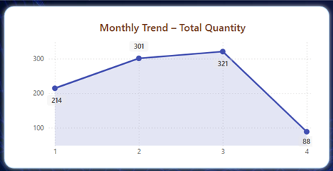
Figure 11: Area Chart

Sales Distribution by Product Category (Funnel Chart):

• Insights: Shows how sales quantities are distributed across product categories (Furniture, Technology, Office Supplies).
• Why this chart? Funnel charts are useful to visualize progression or filtering through stages or groups.
• Benefits: Highlights which categories dominate in volume.
• Decisions: Focus inventory and promotions on the most sold categories.

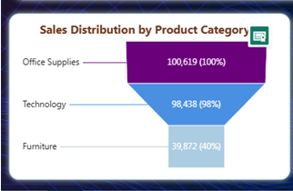
Figure 12: Funnel Chart

Median of Total Sales by Category (Donut Chart):
• Insights: Illustrates the median value of sales per product category.
• Why this chart? Donut charts provide a clear view of relative proportions.
• Benefits: Understand central performance tendency of each category.
• Decisions: Rebalance the product mix or pricing strategy based on performance.

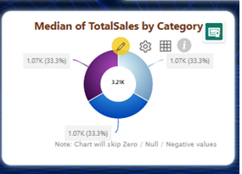
Figure 13:Dount Chart

Sales Contribution by Country (Ring Chart):
• Insights: Shows the percentage contribution of each country to the total sales.
• Why this chart? Donut charts are effective for comparing parts to the whole.
• Benefits: Quickly identifies top-performing countries.
• Decisions: Allocate resources and market focus based on country performance.
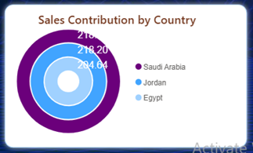
Figure 14: Ring Chart

Drill Through:
Drill Through allows users to navigate from a summary view to a detailed report page that focuses on a specific data point (such as a product category, customer, or region). It helps you analyze deeper insights related to a particular item.
You can click on a specific category in this chart and choose “Drill through” to go to another report page where you can see detailed information related only to that category.
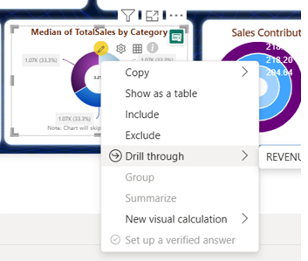
Figure 15: Drill Through

Drill Up:
Drill up is a technique that allows you to navigate from a detailed, lower view of data to a higher, more aggregated level within a hierarchical data structure. It’s essentially the reverse operation of drilling down.
Purpose:
The main goal of drilling up is to gain a broader overview of the data, simplify the visualization, or see trends at a higher level. For example, if you’ve drilled down to see daily sales, you might drill up to see monthly or quarterly sales to identify overall performance trends.
How it Works:
Drill up lets you move from a detailed view (like monthly data) to a higher-level summary (like quarterly or yearly data) by clicking the "Drill up" icon—usually an upward arrow. It aggregates lower-level data into broader categories, helping you see overall trends.
In summary, the “Drill up” feature provides a way to step back from detailed monthly revenue figures to a more generalized view, helping users understand the bigger picture without being overwhelmed by granular data.
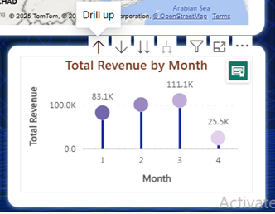
Figure 16: Drill Up

Drill Down:
Drill Down allows you to explore data in more detail.
Drill down is a technique that lets you navigate from a high-level, summarized view of data to more specified levels within a hierarchical data structure.
Purpose:
The main goal of drilling down is to gain deeper insights, identify trends, outliers, or correlations that might not be visible in an aggregated view. It helps you understand the underlying factors contributing to the data you’re seeing.
How it Works:
◦ Hierarchical Data: For drill down to work, your data needs to be organized in a hierarchy. The chart is titled “Total Revenue by Day,” and the axis is labeled “Month.” This suggests a time-based hierarchy (e.g., Year > Quarter > Month > Day). You might initially see total revenue by month, and then drill down to see it by day, or even by hour.

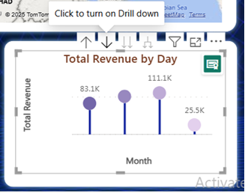
Figure 17: Drill Down

Monthly Revenue by Product Category (Line Chart):
• Insights: Reveals how revenue changes month by month for each product category.
• Why this chart? Tracks changes in performance over time.
• Benefits: Detects performance trends in specific product categories.
• Decisions: Plan inventory or promotions based on peak revenue months.
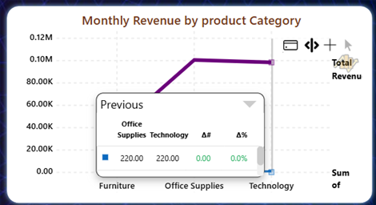
Figure 18:Line and Bar combo chart

Sales Performance by Country (Map):
• Insights: Visualizes sales intensity by country using geographic data.
• Why this chart? Maps are excellent for regional performance comparisons.
• Benefits: Understand geographic strengths and weaknesses.
• Decisions: Expand into high-performing regions or address low-performing ones.
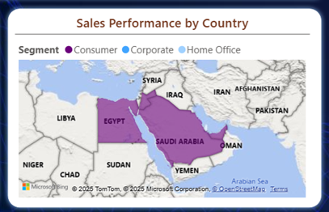
Figure 19: Map Chart

Revenue Per Unit Analysis (Bar Chart):

• Insights: Compares revenue per unit sold across different categories or products.
• Why this chart? Bar charts clearly compare numerical values.
• Benefits: Helps understand profitability per item.
• Decisions: Promote high-margin products or revise pricing.
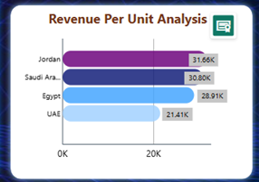
Figure 20:Horizontal bar chart

Customer Segment Distribution (Waterfall Chart):
• Insights: Shows how total sales are divided among different customer segments.
• Why this chart? Stacked bars show both total and proportion per category.
• Benefits: See the share of each segment in the total mix.
• Decisions: Balance customer outreach and tailor communications.
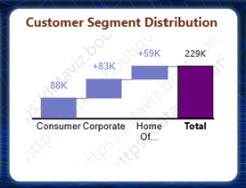
Figure 21: Waterfall Chart

Total Revenue by Month (Column Chart):
• Insights: Displays overall revenue trends month by month.
• Why this chart? Column charts show comparison over time effectively.
• Benefits: Highlights the best and worst revenue months.
• Decisions: Optimize resource allocation and marketing based on monthly performance.
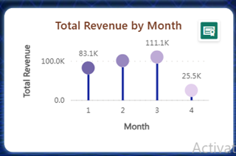
Figure 22:lollipop chart

Reference:
https://youtu.be/V-s8c6jMRN0?si=N-5tRerXoKov_OOD

Conclusion:
This dashboard is a powerful tool that helps stakeholders quickly assess company performance across various dimensions. Each visual provides valuable insights that support strategic decisions, such as which market to expand into, which product lines to promote, or how customer segments perform over time. Its interactive nature allows users to filter by country, month, or category, making it adaptable for multiple business questions.

Figure 1: Fact Sales Clean 4
Figure 2: Dimension Region Clean 5
Figure 3: Dimension Products Clean 6
Figure 4: Dimension Time Clean 7
Figure 5: Dimension Customers Clean 8
Figure 6: Model View 9
Figure 7: Sales Analysis 10
Figure 8: Revenue Analysis 11
Figure 9: Cards 11
Figure 10: clustered bar chart 13
Figure 11: Area Chart 14
Figure 12: Funnel Chart 15
Figure 13:Dount Chart 15
Figure 14: Ring Chart 16
Figure 15: Drill Through 17
Figure 16: Drill Up 18
Figure 17: Drill Down 19
Figure 18:Line and Bar combo chart 19
Figure 19: Map Chart 20
Figure 20:Horizontal bar chart 21
Figure 21: Waterfall Chart 21
Figure 22:lollipop chart 22

